Aim : Image Processing
GitHub : https://github.com/mankumarbhalodiya/Digital-Signal-and-Image-Processing/tree/main/Experiment%207
1. Introduction : Gray-level transformation is an image enhancement technique in which the intensity value of each pixel is changed to improve the visual quality of an image.
The general transformation is represented as : s=T(r)
Where:
- r = original pixel intensity
- s = transformed pixel intensity
- T = transformation function
For an 8-bit grayscale image: 0≤r,s≤255

2. Contrast Stretching
Contrast stretching improves images with low contrast by expanding the range of pixel intensities. It makes dark areas darker and bright areas brighter, improving overall image clarity.

3. Histogram Equalization
Histogram equalization improves image contrast by redistributing the intensity values. It helps reveal details that may not be clearly visible in the original image.

4. Gamma Transformation
Gamma transformation changes the brightness of an image using a nonlinear intensity adjustment. A gamma value less than 1 mainly brightens dark regions and reveals hidden details.

5. Log Transformation
Log transformation enhances details in dark regions of an image. It increases the visibility of low-intensity pixels while reducing the effect of very bright pixels.

6. Image Negative
Image negative reverses the brightness of an image. Dark regions become bright and bright regions become dark, which can make certain details easier to observe.

7. Histogram
A histogram shows how pixel intensity values are distributed in an image. Comparing original and enhanced histograms helps analyze the effect of each enhancement technique.

Code :
import glob, os
import cv2, numpy as np
import matplotlib
matplotlib.use('Agg')
import matplotlib.pyplot as plt
BASE_DIR = os.path.dirname(os.path.abspath(__file__))
IMAGE_DIR = os.path.join(BASE_DIR, "images")
files = [os.path.join(IMAGE_DIR, f"{i}.jpg") for i in range(1, 6)]
for f in files:
if not os.path.exists(f):
files = sorted(glob.glob(os.path.join(IMAGE_DIR, "*")))[:5]
break
images = [cv2.imread(f, cv2.IMREAD_GRAYSCALE) for f in files]
def contrast_stretch(img):
min_val, max_val = np.min(img), np.max(img)
if max_val == min_val:
return img
return np.uint8((img.astype(np.float32) - min_val) * 255.0 / (max_val - min_val))
def histogram_equalization(img):
return cv2.equalizeHist(img)
def gamma_correction(img, gamma=0.4):
norm = img / 255.0
return np.uint8(np.power(norm, gamma) * 255.0)
def log_transform(img):
norm = img.astype(np.float32)
c = 255.0 / np.log(1.0 + np.max(norm))
return np.uint8(c * np.log1p(norm))
def image_negative(img):
return 255 - img
methods = [
("Contrast Stretching", contrast_stretch),
("Histogram Equalization", histogram_equalization),
("Gamma Transformation (γ=0.4)", gamma_correction),
("Log Transformation", log_transform),
("Image Negative", image_negative)
]
enhanced_images = []
for i, (name, func) in enumerate(methods):
enh = func(images[i])
enhanced_images.append(enh)
cv2.imwrite(os.path.join(BASE_DIR, f"enhanced_image_{i+1}.png"), enh)
fig, axes = plt.subplots(5, 2, figsize=(10, 18))
for i in range(5):
name, _ = methods[i]
axes[i, 0].imshow(images[i], cmap="gray")
axes[i, 0].set_title(f"Image {i+1} - Original", fontsize=11, fontweight="bold")
axes[i, 0].axis("off")
axes[i, 1].imshow(enhanced_images[i], cmap="gray")
axes[i, 1].set_title(f"Image {i+1} - {name}", fontsize=11, fontweight="bold")
axes[i, 1].axis("off")
plt.tight_layout()
plt.savefig(os.path.join(BASE_DIR, "comparison_results.png"), dpi=300, bbox_inches="tight")
plt.close()
fig_hist, axes_hist = plt.subplots(5, 2, figsize=(12, 16))
for i in range(5):
name, _ = methods[i]
axes_hist[i, 0].hist(images[i].ravel(), bins=256, range=[0, 256], color="gray", alpha=0.8)
axes_hist[i, 0].set_title(f"Image {i+1} Original Histogram", fontsize=10)
axes_hist[i, 0].set_xlim([0, 256])
axes_hist[i, 1].hist(enhanced_images[i].ravel(), bins=256, range=[0, 256], color="indigo", alpha=0.8)
axes_hist[i, 1].set_title(f"Image {i+1} Enhanced Histogram ({name})", fontsize=10)
axes_hist[i, 1].set_xlim([0, 256])
plt.tight_layout()
plt.savefig(os.path.join(BASE_DIR, "histogram_analysis.png"), dpi=300, bbox_inches="tight")
plt.close()

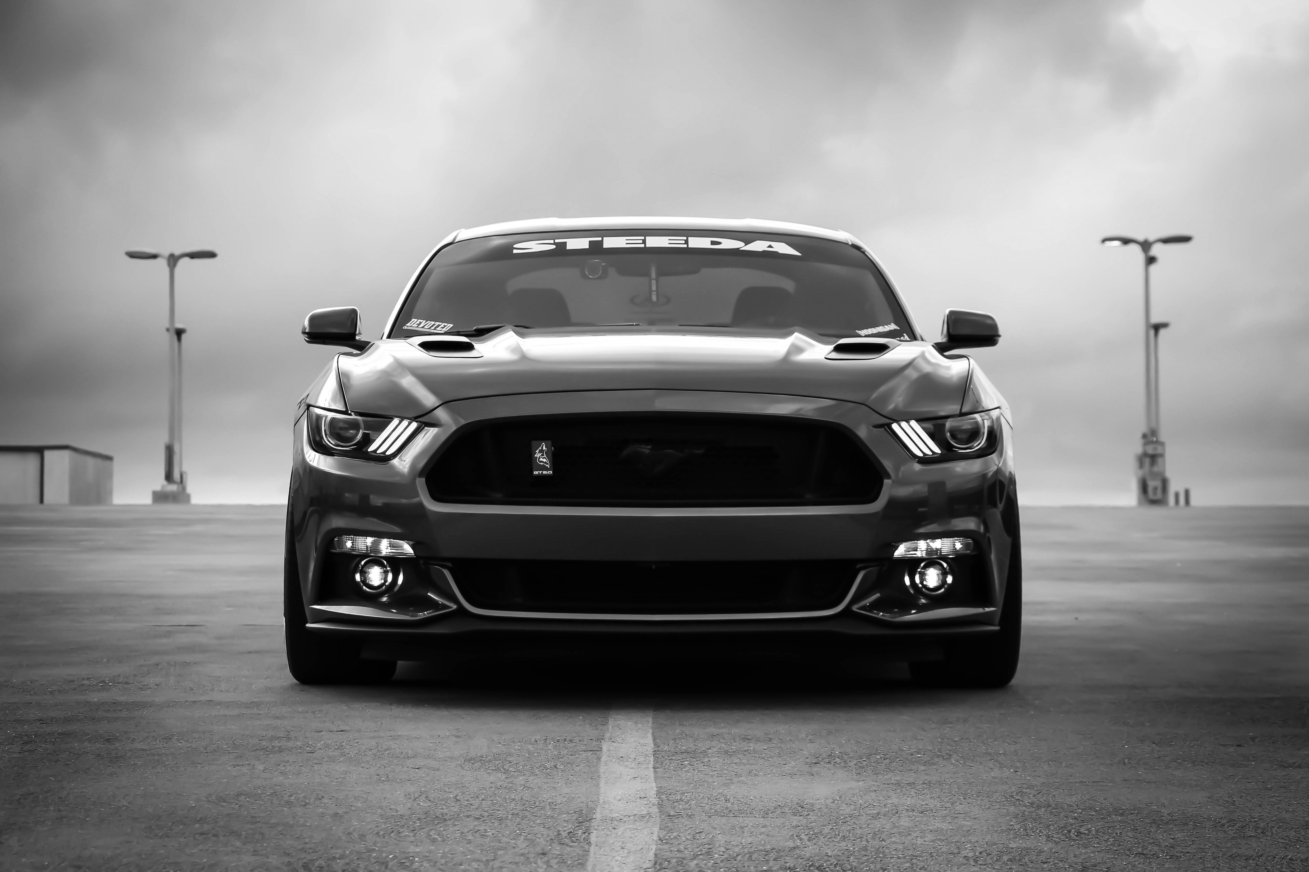
Outputs :

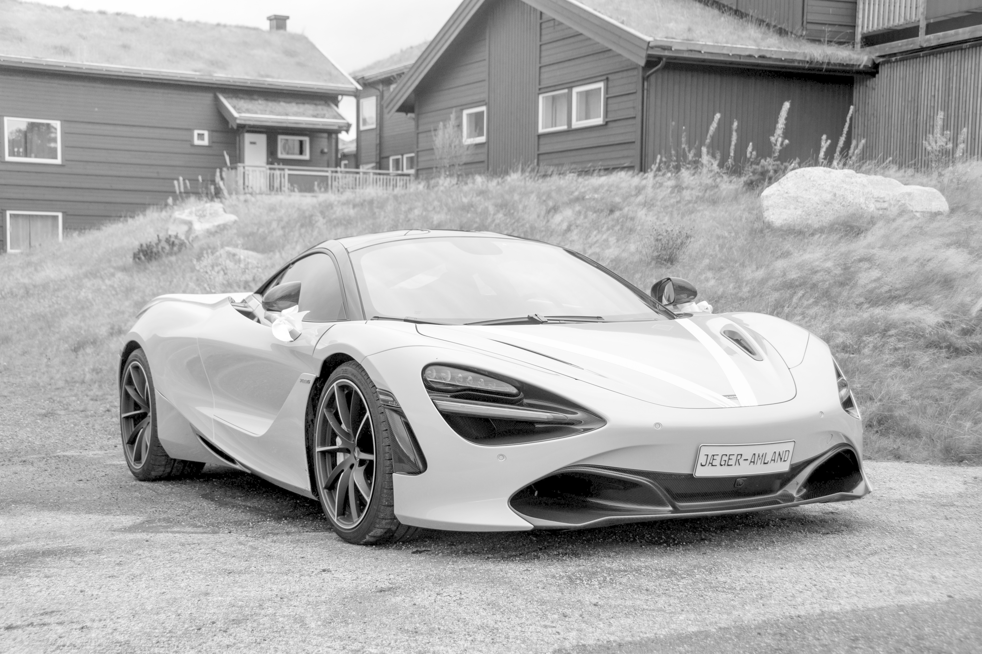

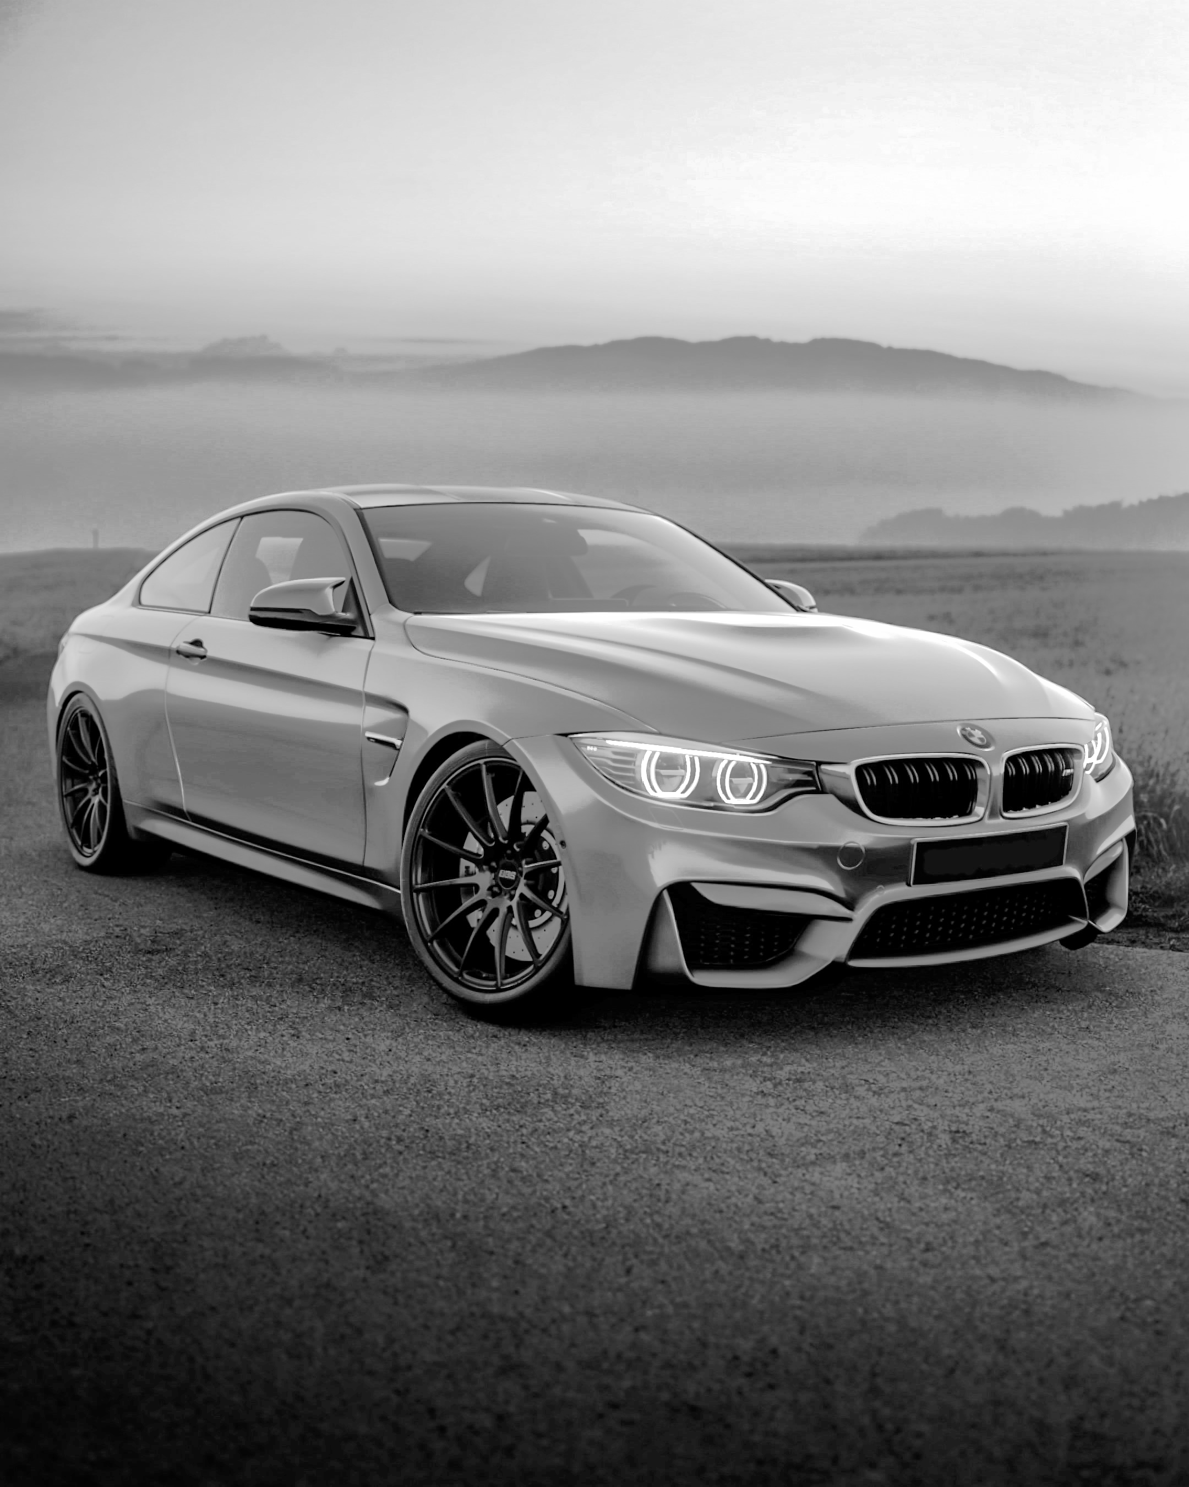

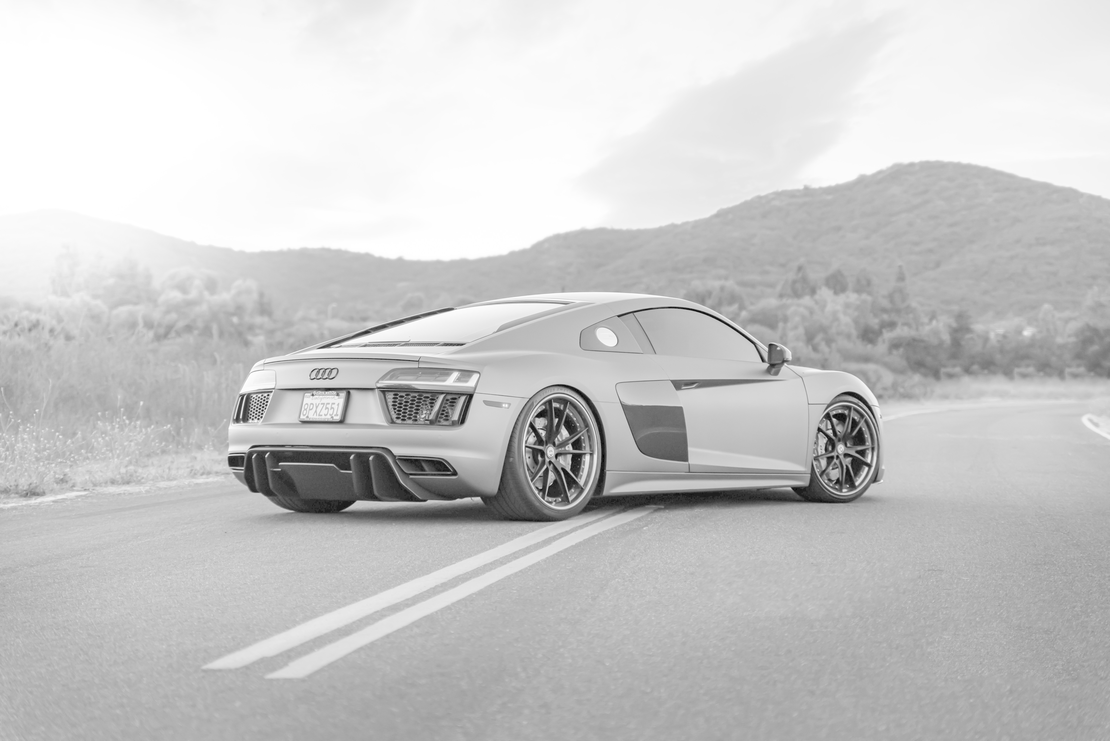
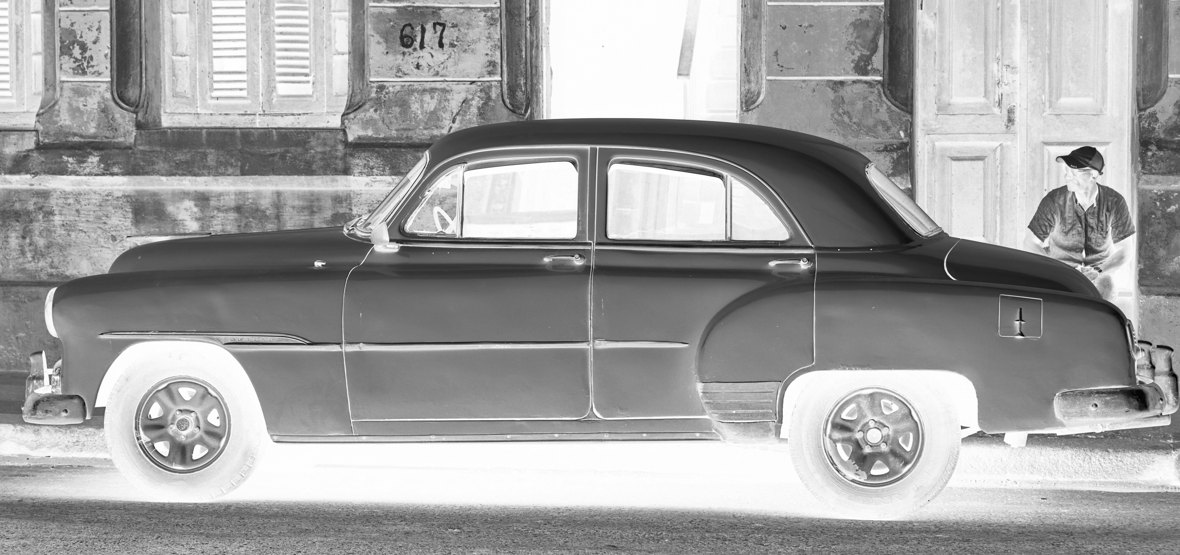
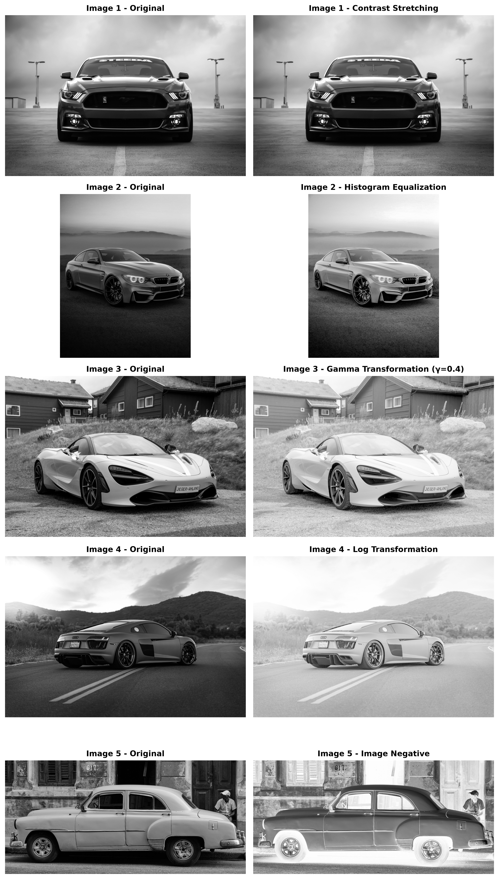
Conclusion : The experiment successfully demonstrated different gray-level transformation techniques for image enhancement. Contrast stretching, histogram equalization, gamma transformation, log transformation, and image negative improved the visibility and contrast of different types of images. The histogram comparison also helped analyze the changes in pixel intensity distribution. Overall, gray-level transformations are simple and effective techniques for improving image quality and highlighting important image details.

